**DWBI**

Q1. Find the total sales by country_id and channel_desc for the US and GB through the Internet and direct sales in September 2000 and October 2000 using ROLL-UP Extension. and country_iso_code for each channel_desc value.

QUERY:

SELECT channels.channel_desc,calendar_month_desc,countries.country_iso_code,

TO_CHAR(SUM(amount_sold), '9,999,999,999') AS SALES$

FROM sales

JOIN customers ON sales.cust_id = customers.cust_id

JOIN times ON sales.time_id = times.time_id

JOIN channels ON sales.channel_id = channels.channel_id

JOIN countries ON customers.country_id = countries.country_id

WHERE channels.channel_desc IN ('Direct Sales', 'Internet')

AND times.calendar_month_desc IN ('2000-09', '2000-10')

AND countries.country_iso_code IN ('GB', 'US')

GROUP BY ROLLUP(channels.channel_desc, calendar_month_desc, countries.country_iso_code); 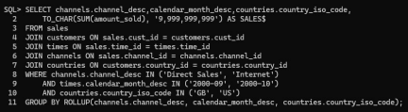

O/P:

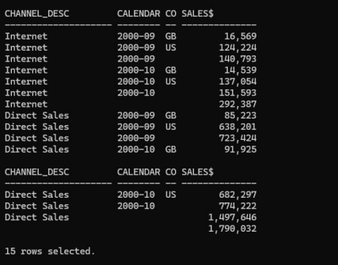

Q2. Find the total sales by country_iso_code and channel_desc for the US and GB through the Internet and direct sales in September 2000 and October 2000 using CUBE aggregation across three dimensions- channel_desc, calendar_month_desc, countries. country_iso_code.

QUERY:

SELECT channels.channel_desc, times.calendar_month_desc, countries.country_iso_code,

TO_CHAR(SUM(sales.amount_sold), '9999999999') AS SALES$

FROM sales JOIN customers ON sales.cust_id = customers.cust_id

JOIN times ON sales.time_id = times.time_id

JOIN channels ON sales.channel_id = channels.channel_id

JOIN countries ON customers.country_id = countries.country_id

WHERE channels.channel_desc IN ('Direct Sales', 'Internet') AND

times.calendar_month_desc IN ('2000-09', '2000-10')

AND countries.country_iso_code IN ('GB', 'US')

GROUP BY CUBE(channels.channel_desc, times.calendar_month_desc, countries.country_iso_code); 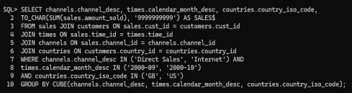

O/P:

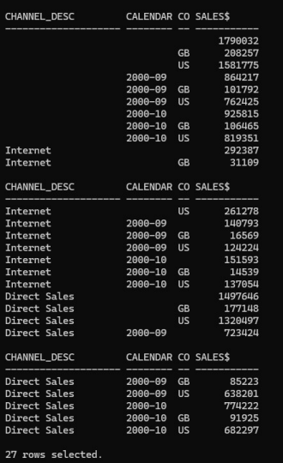

Q3. Find the total sales by country_iso and channel_desc for the US and France through the Internet and direct sales in September 2000

QUERY:

SELECT channels.channel_desc, countries.country_iso_code,

TO_CHAR(SUM(sales.amount_sold), '9999999999') AS SALES$ FROM sales

JOIN customers ON sales.cust_id = customers.cust_id

JOIN channels ON sales.channel_id = channels.channel_id

JOIN countries ON customers.country_id = countries.country_id

JOIN times ON sales.time_id = times.time_id

WHERE channels.channel_desc IN ('Direct Sales', 'Internet')

AND times.calendar_month_desc = '2000-09'AND

countries.country_iso_code IN ('US', 'FR')

GROUP BY countries.country_iso_code, channels.channel_desc;

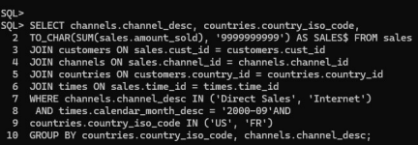

O/P:

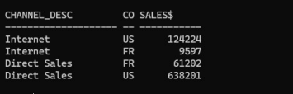

Q4. Find the total sales by country_iso and channel_desc for the US and GB through the Internet and direct sales in September 2000 and October 2009 using PARTIAL ROLL-UP.

QUERY:

SELECT channels.channel_desc, times.calendar_month_desc, countries.country_iso_code, TO_CHAR(SUM(sales.amount_sold), '9999999999') AS SALES$

FROM sales JOIN customers ON sales.cust_id = customers.cust_id

JOIN channels ON sales.channel_id = channels.channel_id

JOIN countries ON customers.country_id = countries.country_id

JOIN times ON sales.time_id = times.time_id

WHERE channels.channel_desc IN ('Direct Sales', 'Internet')

AND times.calendar_month_desc IN ('2000-09', '2009-10')

AND countries.country_iso_code IN ('GB', 'US')

GROUP BY channels.channel_desc,

ROLLUP(times.calendar_month_desc, countries.country_iso_code);

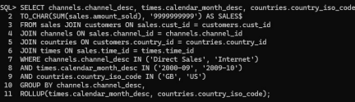

O/P:

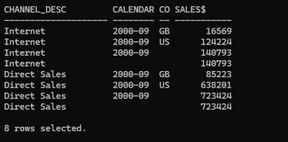

Q5. Find the total sales by country_id and channel_desc for the US and GB through the Internet and direct sales in September 2000 and October 2009 using PARTIAL CUBE aggregation on month and country code and GROUP BY on channel_desc.

QUERY:

SELECT channels.channel_desc, times.calendar_month_desc, countries.country_iso_code,

TO_CHAR(SUM(sales.amount_sold), '9999999999') AS SALES$

FROM sales JOIN customers ON sales.cust_id = customers.cust_id

JOIN channels ON sales.channel_id = channels.channel_id

JOIN countries ON customers.country_id = countries.country_id

JOIN times ON sales.time_id = times.time_id

WHERE channels.channel_desc IN ('Direct Sales', 'Internet')

AND times.calendar_month_desc IN ('2000-09', '2009-10')

AND countries.country_iso_code IN ('GB', 'US')

GROUP BY GROUPING SETS(

(channels.channel_desc, times.calendar_month_desc, countries.country_iso_code),

(channels.channel_desc, countries.country_iso_code),

(times.calendar_month_desc, countries.country_iso_code)

);

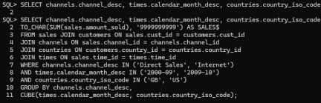

O/P:

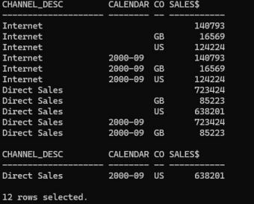

Q6. Use GROUPING to create a set of mask columns for the result set of Q1. Create grouping on channel_desc and name it as CH

Create grouping calendar_month_desc and name it as MO

Create grouping on country_iso_code and name it as CO

QUERY:

SELECT channel_desc, calendar_month_desc, country_iso_code,

TO_CHAR(SUM(amount_sold), '9,999,999,999') SALES$, GROUPING(channel_desc) AS

Ch,

GROUPING(calendar_month_desc) AS Mo, GROUPING(country_iso_code) AS Co

FROM sales, customers, times, channels, countries

WHERE sales.time_id=times.time_id

AND sales.cust_id=customers.cust_id

AND customers.country_id = countries.country_id

AND sales.channel_id= channels.channel_id

AND channels.channel_desc IN ('Direct Sales', 'Internet')

AND times.calendar_month_desc IN ('2000-09', '2000-10')

AND countries.country_iso_code IN ('GB','US')

GROUP BY ROLLUP(channel_desc, calendar_month_desc,

countries.country_iso_code);

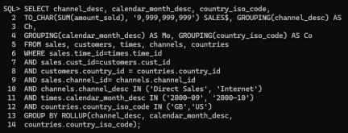

O/P:

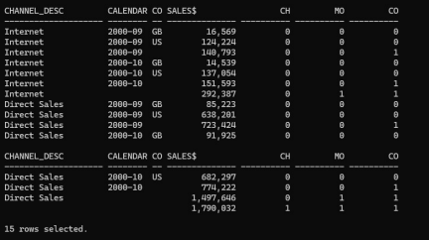

Q7. Find the total sales by country_id and channel_desc for the US and GB through the Internet and direct sales in September 2000 and October 2009 using GROUPING SETS. Calculate aggregates over three groupings:

(channel_desc, calendar_month_desc, country_iso_code)

(channel_desc, country_iso_code)

(calendar_month_desc, country_iso_code)

QUERY:

SELECT channels.channel_desc, times.calendar_month_desc, countries.country_iso_code, TO_CHAR(SUM(sales.amount_sold), '9999999999') AS SALES$

FROM sales JOIN customers ON sales.cust_id = customers.cust_id

JOIN channels ON sales.channel_id = channels.channel_id

JOIN countries ON customers.country_id = countries.country_id

JOIN times ON sales.time_id = times.time_id

WHERE channels.channel_desc IN ('Direct Sales', 'Internet')

AND times.calendar_month_desc IN ('2000-09', '2009-10')

AND countries.country_iso_code IN ('GB', 'US')

GROUP BY GROUPING SETS(

(channels.channel_desc, times.calendar_month_desc, countries.country_iso_code),

(channels.channel_desc, countries.country_iso_code),

(times.calendar_month_desc, countries.country_iso_code)

);

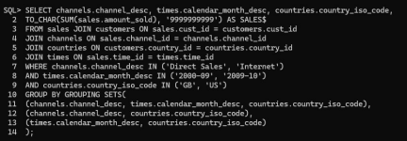

O/P:

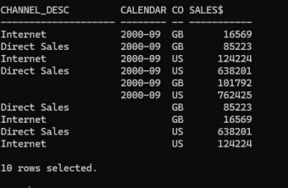

Q8. Consider the following Query and make conclusion from the result obtained. (scott Schema)

QUERY:

SELECT deptno,job,SUM(sal)

FROM emp

GROUP BY CUBE(deptno,job);



O/P:



Q9. Calculate the salary for each department present in different cities of hr schema using rollup. QUERY:

SELECT departments.department_id, locations.city, SUM(employees.salary) AS total_salary FROM employees

JOIN departments ON employees.department_id = departments.department_id

JOIN locations ON departments.location_id = locations.location_id

GROUP BY ROLLUP (departments.department_id, locations.city);

O/P:



Q10. Calculate the salary for each department present in different cities of hr schema using cube.

QUERY:

SELECT departments.department_id, locations.city, SUM(employees.salary) AS total_salary

FROM employees

JOIN departments ON employees.department_id = departments.department_id

JOIN locations ON departments.location_id = locations.location_id

GROUP BY CUBE (departments.department_id, locations.city);

O/P:



CONCLUSION:

In this practical, we explored the use of SQL aggregation techniques like ROLLUP, CUBE, and GROUPING SETS. These tools help in summarizing data efficiently across multiple dimensions, which is crucial for data warehousing. By applying these methods, we can generate detailed and high-level summaries with minimal effort, enhancing the performance and scalability of data analysis tasks.